Zvolen Castle’s new collection display will present an iconic personality of Slovak architecture – Dušan Jurkovič

Bratislava, 14 August 2023 | Zvolen Castle’s new collection display Visiting Dušan Jurkovič exhibits the work of this prominent architect, designer, ethnographer, and publicist. Presented in a stylized showroom, you will view a set of furniture that Jurkovič designed for his bedroom and study, complemented by ceramics, textile works, photographs, and drawings. Opening of the display to the public will be on Thursday 24 August 2023.
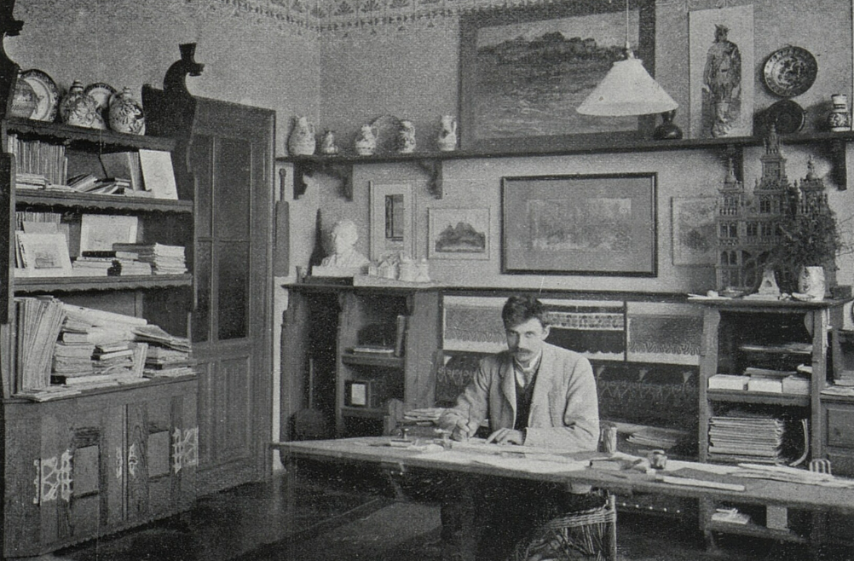
Dušan Jurkovič is an iconic personality of 20th century Slovak architecture. Creator of The Cairn of Milan Rastislav Štefánik at Bradlo, he was also active outside Slovakia, and had interests beyond architecture. He was a furniture designer, ethnographer, and publicist who lived and worked in Moravia for almost 30 years. His wide range of interests is captured by the new collection display Visiting Dušan Jurkovič, which takes the form of a stylized room – much as Jurkovič created in his house in Brno-Žabovřesky, where at the beginning of the 20th century he hosted exhibitions of architecture and applied art. Individual design elements of the display relate to the various fields that Jurkovič was engaged with during his lifetime.
“We have placed pieces of ceramics in Jurkovič’s furniture just like he used to. This provided us with an opportunity to tap into the gallery collections of art crafts and to present artefacts of the manufactories in Holíč and Kremnica, Italian and French ceramics, and the work of the ceramist and jug maker Ferdiš Kostka, Jurkovič’s peer, with whom he was jointly awarded the accolade of National Artist in 1946," explain the display's curators, Viera Kleinová and Jana Švantnerová from the Slovak National Gallery.
Other elements of the room, such as the tapestries, relate to Jurkovič’s connection with the Moravian Tapestry Manufactory in Valašské Meziříčí. The model of the villa at Rezek, in turn, alludes to Jurkovič as an architect and at the same time is a reference to his personal life – while designing the villa, he met his future wife Božena.
Also available in digital form in the display are the author's notebooks Práce lidu našeho (Works of Our People), in which he mapped traditional Slovak architecture and craftsmanship, and through which visitors can learn about his interest in ethnography. In addition, Jurkovič was involved in the protection of our heritage. "This author is linked to Zvolen Castle through an unrealised project for its restoration from the 1920s, and through the construction of an apartment house on Štefan Moyzes Street, which is inspired by the castle’s architecture and decorative details", adds Denis Haberland, co-curator of the collection display from the SNG.
Dušan Samuel Jurkovič (1868–1947)
The most important personality of Slovak architecture of the 20th century, he studied architecture in Vienna. He apprenticed at the studio of Blažej Bulla in Martin, and later at Michal Urbánek in Vsetín. From 1899, he worked as an independent architect in Brno, finally settling in Bratislava in 1918. Throughout his lifetime he studied folk architecture, the results of which he published in the notebooks Práce lidu našeho (Works of Our People). These were also the basis for his early architectural work at the turn of the 20th century, which ranks among the best works of European Secession. During the First World War, he was active in Western Galicia, where he designed and realised thirty military cemeteries. Culmination of this period of his work was the design of The Cairn of Milan Rastislav Štefánik at Bradlo.

Curators of the Collection Display: Viera Kleinová, Jana Švantnerová, Denis Haberland
Technical Support: Samuel Antol, Samuel Chovanec
Digital Content of the Collection Display: lab.SNG
Graphic Design: Kristína Uličná
Opening of the Collection Display: 24 August 2023 at 5 p.m., Admission from: 25 August 2023

For up-to-date information about exhibitions, collection displays, events, and news from the SNG, please visit www.sng.sk, our social media channels, or subscribe to our gallery newsletter at www.sng.sk.

General partner of the SNG


