Slovak National Gallery abounds with art –
opening of three new collection displays
Bratislava, 22 June 2023 | From Friday 23 June 2023, Slovak National Gallery visitors will be able to view the gallery’s first long-term collection displays, with focus on Slovak modern art of the first half of the 20th century, and sacred art from the Gothic and Baroque periods. The gallery will also re-open its popular experimental displays, including a new section devoted to the art historian and bibliophile Igor Gazdík. Inaugural curatorial interpretations will take place in the display areas from Friday to Sunday.
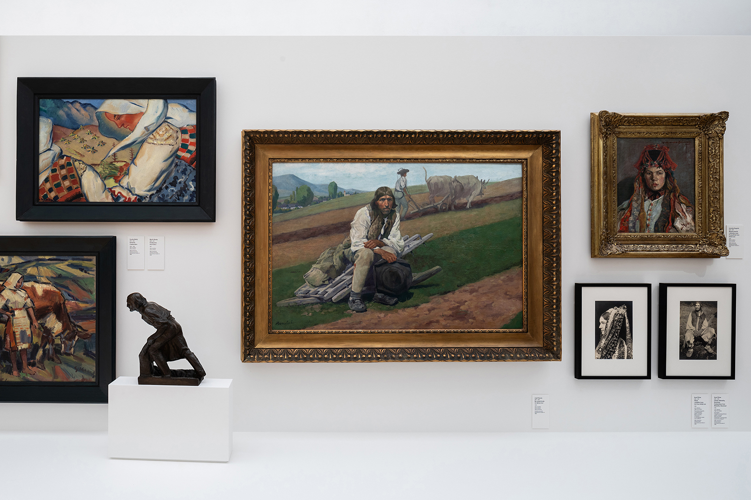
The Modern and Sacred Art are the first of six long-term SNG collection displays that will occupy the gallery's exhibition spaces. The Modern introduces the story of Slovak visual art of the first half of the 20th century. "We have selected the most important developments in our art between 1890/1900 and 1948. Visitors will discover how art responded to new civilisational challenges and social transformations, how artists reacted to the world they lived in, and how these realities were reflected in their works, so changing the imagery and language of visual art," says Katarína Bajcurová, the display’s curator. Key points are highlighted by the inclusion of several artworks from the second half of the 20th century that indicate the affinity of certain semantic codes and images, a shift in their understanding, and their transformation over time.
In the Sacred Art display, visitors will discover the SNG’s most precious Gothic and Baroque paintings and sculptures, as well as icons and paintings from European art of the 16th to the 19th century. The display guides visitors through several themes and aspects associated with religious art, such as Passions, Holy Family, Folk Piety, and Original & Copy, ultimately arriving at a group of the oldest wooden sculptures in Slovakia. "Although the SNG owns probably the richest collection of sacred art among public institutions, its focus on Christian paintings and sculptures somewhat distorts the overall view. We therefore intend occasionally to enrich the display with cult objects from other major religions. Similarly, drawings, prints, and photographs, which are more sensitive to long-term exhibiting, will be added for a shorter period," explain the display’s curators Dušan Buran & Katarína Kolbiarz Chmelinová.
From Friday 23 June, following a brief break, SNG visitors may again view the experimental collection displays at the Esterházy Palace, now renamed Esterházy, including the popular interactive projection Amazing Art History with Professor Hamster, the unique Kornel and Naďa Földvári Library, and the Antimuseum of J.K. This unconventional format will be complemented by the new display Biblioman. Bibliophile books and book design from the collection of Igor Gazdík.
Comprising several thousand items, the collection of Igor Gazdík, theoretician and art historian, librarian and bibliophile, was in fact a residential library compiled over many years. It contained art historical publications, books from other humanities, fiction, poetry, and Slovak, Czech, and foreign language titles, as well as "little books", as Igor Gazdík affectionately named them. "We are presenting a selection of his bibliophilia at the SNG in an authorial re-design of a living room set in the times of normalisation by designer Sylvia Jokelová," says Viera Kleinová, the display’s curator. Visitors will take visual pleasure in the book covers and frontispieces, and may browse through the books in the intimate reading corner.
Additionally, for the occasion of the opening of the collection displays, the SNG introduces the large-scale graphic In the Name of the Pentode – Everything Is as It Really Is by contemporary artists Pavol Čejka, Jan Čumlivský, and Tomáš Klepoch. Measuring ten and a half square metres, this engraving is part of the ongoing SNG project Art in the Public Space. Fusion of art and architecture. The main motif of the work draws upon historical events, cultural history, conspiracy theories, and dialogue with graphic, literary, and philosophical traditions. Impetus for its creation was a proliferation of conspiracy theories in the area of Banská Štiavnica, where the authors first worked on it. Its base is formed of old lino, which they jointly engraved for three years across various locations.
From the completed engraving, the authors created a series of unique books that are a precise 1:1 scale map of the work. The publication In the Name of the Pentode is available at the SNG Ex Libris bookshop. Book guides to The Modern and Sacred Art collection displays are also available in the gallery's bookshop and from the SNG's e-shop. As the SNG announced through its ongoing communication, it will progressively continue to fill the gallery space with equipment, services, and art throughout this year. The remaining four long-term collection displays will open by the first half of 2024, and in the meantime several short-term exhibitions will be staged.

Events
23/6
Curatorial interpretation in the Biblioman collection display by Viera Kleinová
Friday / 16:00 / Esterházy – entrance from the 2nd floor of the Water Barracks / language: Slovak
Tickets: €4 / €2 (students, seniors, disabled persons)

24/6
Curatorial interpretation in the Sacred Art collection display by Dušan Buran and Katarína Kolbiarz Chmelinová
Saturday / 16:00 / Water Barracks – 2nd floor / language: Slovak
Tickets: €8 / €4 (students, seniors, disabled persons)

25/6
Curatorial interpretation in The Modern collection display area by Katarína Bajcurová
Sunday / 16:00 / Water Barracks – 2nd floor / language: Slovak
Tickets: €8 / €4 (students, seniors, disabled persons)

Tickets for curatorial interpretations can be purchased at the SNG ticket office or online from the gallery's website.
For up-to-date information about events, please visit www.sng.sk, gallery’s social media channels, or subscribe to SNG newsletter at www.sng.sk.

The Slovak National Gallery was able to implement new long-term collection displays with additional support from the Ministry of Culture of the Slovak Republic.
The digital layer of the SNG's long-term collection displays within the Making Meaning of Digital Collections project is being created with the support of grants from the EEA and Norway.


General SNG partner


