Ceramics in Harmony with Nature: New exhibition will also be held in the SNG exterior
Bratislava, June 6, 2024│ Starting tomorrow (June 7, 2024) and running until October 6th, the Slovak National Gallery opens the summer season with an exhibition dedicated to the work of ceramic sculptor Jozef Sušienka. The exhibition will include the ceramic sculptures located in the gallery’s exterior. In addition to the exhibition Jozef Sušienka. Lekcia Krajiny (Jozef Sušienka. Landscape Lesson), the SNG plans to open two new expositions and exhibitions in June.
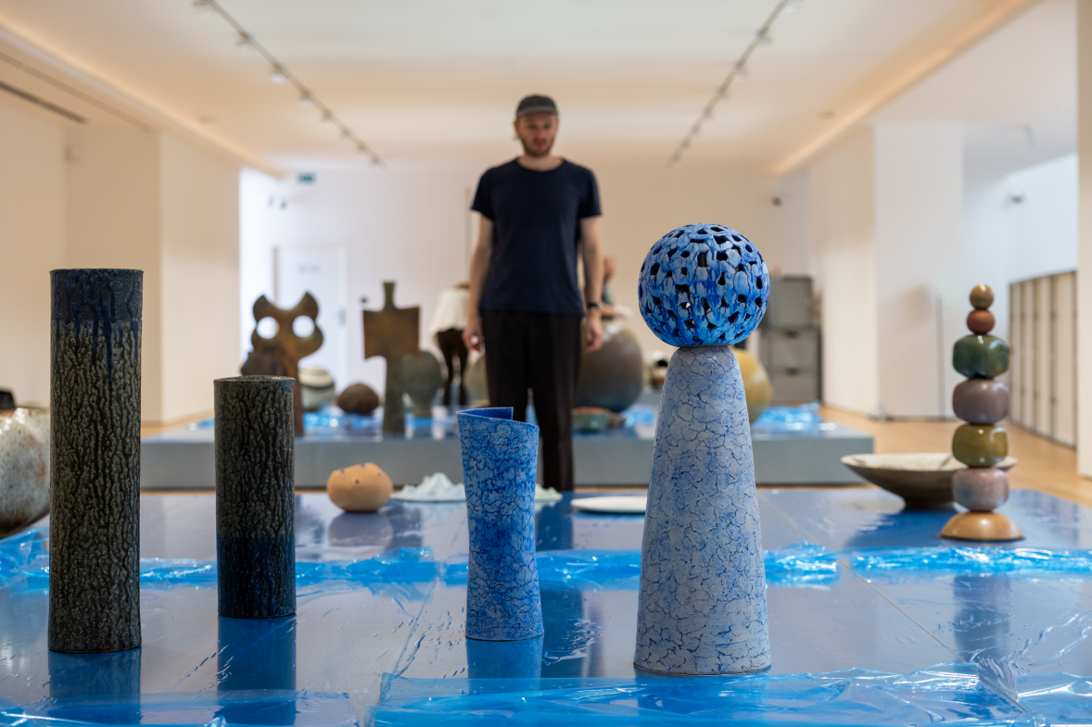
Installation of the exhibition, photo features Maroš Greš – exhibition architect, photo: Juraj Starovecký SNG

Ceramicist and sculptor Jozef Sušienka (1937) returns to the National Gallery after more than 25 years. However, this exhibition is not only a retrospective view of the intense and focused journey of one of the key figures of Slovak ceramic (and other) sculpture and design of the second half of the 20th century. It is also a record of his current work in which he continues to create his Zen-meditative organic assemblages that are anchored in natural processes and forces.
He finds his inspiration mainly in nature which he perceives carefully and sensitively; for example, the bark of a deciduous tree can be transformed into a special glaze. His sculptures, in the form of elemental, biomorphic shapes, often represent a return to the land of his childhood. He has been cultivating the empathetic interplay of nature, ceramics, and mankind since the 1960s - long before ecology became a global challenge and necessity. He believes that ceramics have a place both inside and outside, in the park and in the apartment, and he allows his works to function variably and openly as sculptures, vessels, fountains, luminaires, and tombstones. His Balvany (Boulders), Prašivky (Puffballs), Marťania (Martians), Sovy (Owls), and Ikebanas are thus still living, growing, integrating, and multiplying.
Visitors to the SNG will meet the work of Jozef Sušienka through sculptures, containers, and objects for natural and civilized exteriors, as well as designs and visionary studies and drawings referring to his conceptual thinking. Parková plastika (Park Sculpture), which has been a part of the exhibition entitled Monumentálky (Monumental Sculptures) since 2022, will be complemented in the gallery courtyard by Totemové stĺpy (Totem Columns) from the late 1960s. Visitors will also have an opportunity to see his other work on the Karol Vaculík square stairway on the opposite side of the gallery’s entrance hall. In both places, however, the artist’s unique work will be perceived as a joyful, elemental game and contemplative experience. The exhibition’s interior installation works with reflections and light, thus creating an atmosphere in which the specific glaze of Sušienka’s works will stand out.
The SNG is also preparing a catalog of the same name as the exhibition, which will be on sale a week after the exhibition opens.
In June, the Slovak National Gallery continues with the opening of the exhibition entitled V oku búrky. Umenie secesie na Ukrajine (In the Eye of the Storm. Seccesion in Ukraine), the expositions entitled Dizajn v Kocke (Design Unpacked) and Model: Múzeum súčasného umenia (Model: Museum of Contemporary Art), the exhibition entitled Károly Divald a jeho synovia (Károly Divald and His Sons), and the exposition entitled Európska maľba raného novoveku (European Painting of the Early Modern Period).
Jozef Sušienka (*1937, Nová Bystrica), a co-founder of the Kysuce Regional Gallery, sculpts, designs, paints, and draws. He creates freely modeled ceramic sculptures and vessels, particularly through the use of semi-finished technical ceramics. He is inspired by nature and living organisms, and uses the motifs of growth and division in his creations. The surfaces of his works are scaly, cracked or perforated, and they react to light and work with the reflections of their surroundings, while his glazes emphasize the roundness and softness of the shapes. Roundness, as he says, also refers to the shape of the planet and the flow of water. He is inspired by Japanese gardens and manor parks, but he can also see motifs and shapes in everyday life. In the 1950s, he studied ceramics under Teodor Lugs at the Secondary School of Applied Arts in Bratislava. From there he went to the Czech Republic, where he studied at the Academy of Arts, Architecture and Design in Prague in the Ceramics and Porcelain Studio of Otto Eckert. He has exhibited in France, Italy, Turkey, Japan, and Canada, and has received several awards, including the gold medal at the international exhibition in Faenza, Italy in 1972. He also has fond memories of receiving an honorable mention and plaque from Nagoya, Japan, where he participated in the ceramic design competition in 1973. Jozef Sušienka is a member of the International Academy of Ceramics AIC in Geneva.
The exhibition will run from June 7 to October 6, 2024
1st floor – Hall III, Hall above the Atrium
Exhibition curator: Viera Kleinová
Exhibition architect: Maroš Greš
Graphic design of the exhibition and catalogue: David Kalata
You can also find the current program at www.sng.sk, social networks and in the gallery newsletter, which you can subscribe to at www.sng.sk.
General Partner of the SNG


