The new exhibition at the SNG will present Marko Blažo's oeuvre and provide a glimpse into his creative process
15 February 2024 │ Starting tomorrow, the Slovak National Gallery opens a new exhibition, Marko Blažo: The Whole Humanan. In addition to the artist's creative process, the monographic exhibition also focuses on iconic but also lesser-known or previously unexhibited works. Moreover, on 22 February, visitors will be able to participate in the first presentation with the exhibition's curator. During this guided tour, the curatorial concept and the challenges that had to be dealt with will also be presented along with Marko Blažo's work.
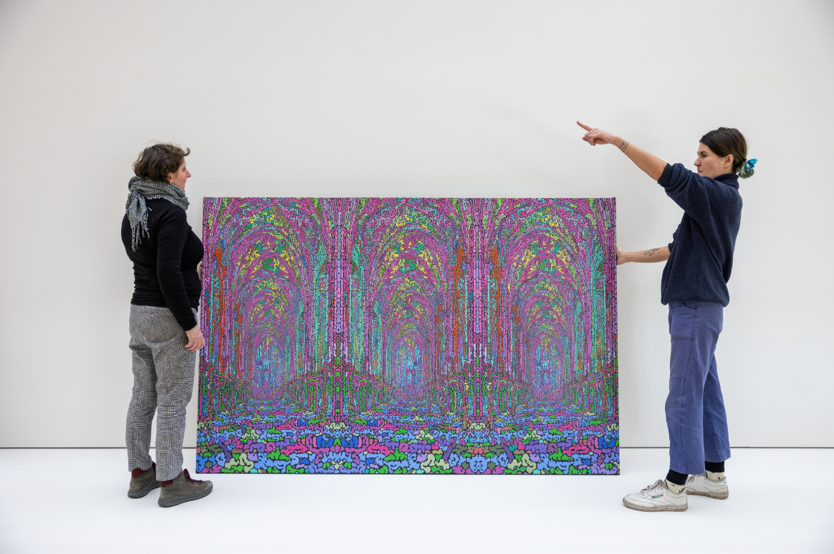
The monographic exhibition of Marko Blažo (1972 – 2021) attempts to present the extensive work of an exceptional artist in a minimalist functionalist box. The exhibition is not organised chronologically but rather arranged based on the recurring motifs across the artist's work, within which everything is interconnected.
"It's actually two exhibitions in one: in the "discovery site of motifs" we mainly present artist's daily, "working" drawings and concepts. In the Bridge, we showcase more monumental realisations, including a black box with immersive penetration into Marko Blažo's head/work computer," says exhibition's co-curator Petra Hanáková.
The unexpectedly deserted oeuvre of Košice artist Marko Blažo belongs to the most original and consistent of his generation. After undergoing graphic training at the ŠUP [a secondary school for visual and applied arts] in Košice, Blažo studied at the Academy of Fine Arts and Design in Bratislava during the early 1990s, where he attended the open atelier of Rudolf Sikora. In a decade when, shortly after the revolution, society was still curious about new art forms, and young people's creativity was stimulated, Blažo's presentations (e.g. chewing gum "paintings" or various surreal objects and situational "game" installations) were immediately recognised for their distinctive poetics. It was a rich, romantic, yet essentially melancholic world.
Exhibition co-curator Alexandra Tamásová explains the artist's work: "Marko Blažo never abandoned his key motifs; his personal mythology was already established in childhood or adolescence. He endlessly varied, layered and updated these motifs. His cosmos is inhabited by trains/train models, or rails, cut heads of cabbage, Ferdo the Ant, architecture (from cathedrals and temples to skyscrapers and little churches, witches' houses to doghouses and birdhouses), razors, chewing gum, Coca-Cola, archaeological sites and excavations, toys in the form of plastic animals and paper cutouts. One of Blažo's work's basic principles was layering and connecting (often disparate) motifs. In other cases, however, we can also observe entropy, crumbling, decay and de-composition."
Marko Blažo (1972 - 2021) lived and worked mainly in his native Košice. He completed his university studies in Rudolf Sikora's open atelier at the Academy of Fine Arts and Design in Bratislava. He was also influenced by his studies abroad, including the École Nationale des Beaux-Arts in Dijon and Slippery Rock University in Pennsylvania. His work has received recognition at home and abroad, including winning at the Contemporary Slovak Graphics in 2005 and receiving awards such as the ArtSlant Award in Los Angeles and the Rector's Award from the Academy of Fine Arts in Cracow. In 2001, he was the laureate of the Oskar Čepan Award.

We would like to thank those who loaned artworks:
Bratislava City Gallery, Ján Koniarik Gallery in Trnava, East Slovak Gallery, National Gallery in Prague, Central Slovak Gallery in Banská Bystrica and private owners and collectors.
We would like to thank the parents of Marko Blažo, especially Katarína Blažová.
Exhibition's Duration: 16. 2. – 19. 5. 2024
Curators: Petra Hanáková, Alexandra Tamásová
You can find the current programme offer at www.sng.sk, on social media, and in the gallery's newsletter, which you can subscribe to at www.sng.sk.


General partner of the SNG

