Slovak National Gallery simultaneously opens three new exhibitions and an international exhibition of Ukrainian Secession
20. 6. 2024 │ SNG will open this Saturday the widest number of new exhibition projects since the gallery was opened after its renovation in 2022. The gallery will fill its space with permanent exhibitions and at the same time open a travelling international exhibition of works of Ukrainian Secession. The audience can look forward to the exhibitions Design Unpacked, European Painting of the Early Modern Period, Model: Museum of Contemporary Art and the exhibition In the Eye of the Storm. Secession in Ukraine.
The Slovak National Gallery closes the main circuit of permanent exhibitions with three new exhibitions Design Unpacked, European Painting of the Early Modern Period, Model: Museum of Contemporary Art. Starting with the opening of the new National Gallery in 2022, it is thus completing long-term exhibition projects that visitors can see over the next few years.
"I am delighted that as an institution we have kept our promise to the public - to have all the exhibitions under roof by the summer. We are thus overcoming a strange period during which art was not sufficiently represented by proper exhibitions offering a comprehensive view of the development of art in Slovakia, which is an important equipment for the representation of the culture of every country," says Alexandra Kusá, Director General of the National Gallery of Art.
In addition, the gallery will also present short-term exhibitions, including a new international exhibition in the Eye of the Storm. Secession in Ukraine, which travels to us from Vienna's Belvedere Gallery and will continue to Sofia, Bulgaria, in September.
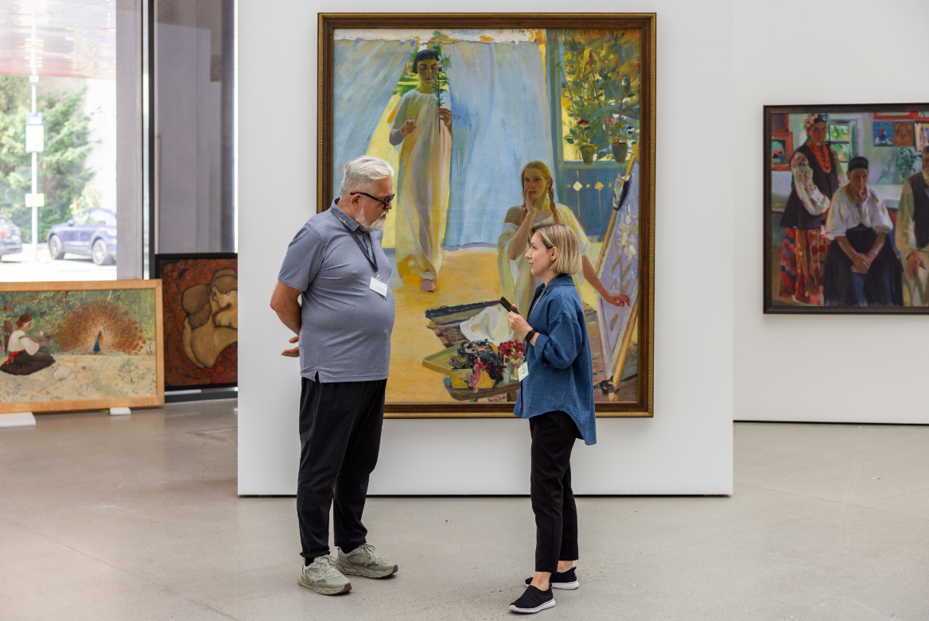
Photo from the installation of the exhibition In the Eye of the Storm. Secession in Ukraine. Ukrainian curators: Konstantin Akinsha, Maryna Drobotiuk

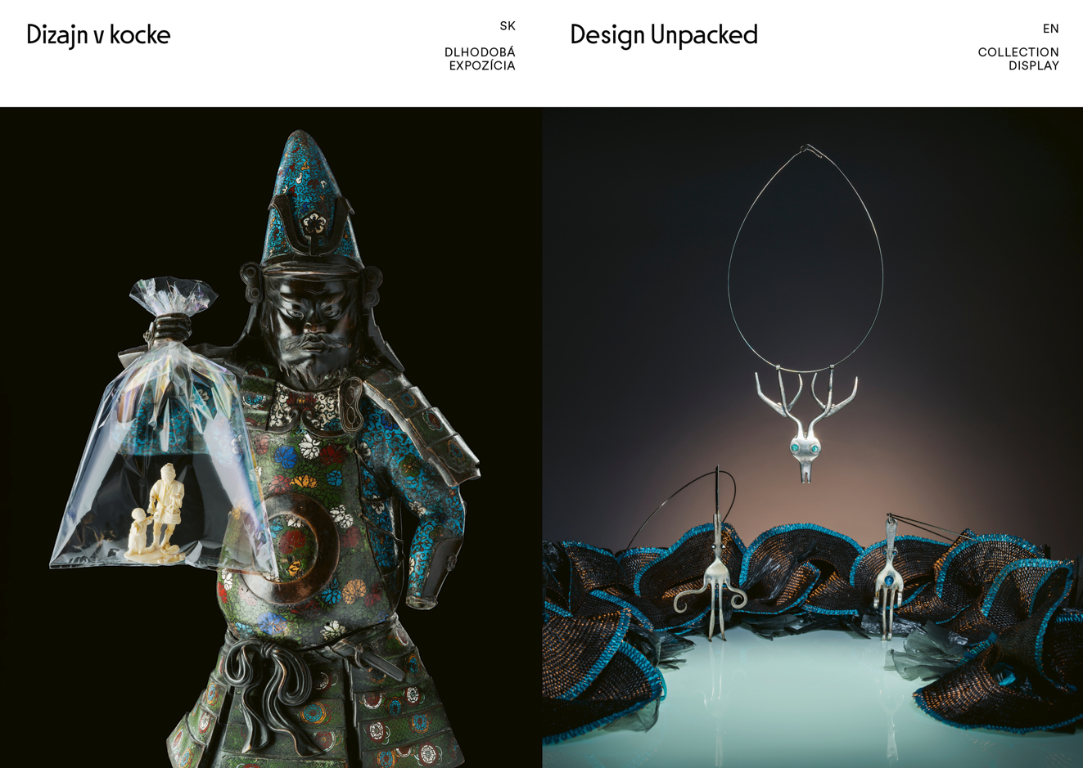
Design Unpacked │ Design, applied arts and artistic craft from the SNG Collections offer an adventure journey across centuries of everyday life and throughout big and small history as well.
You will set off to it accompanied by duos or trios of exhibited artefacts that communicate together in both harmony and tension and which were chosen based on their mutual visual and semantic sparkling. You will see both masterpieces and objects from the back shelves of our depository, progressive works, but even the problematic and controversial ones. You will meet the works of Slovak designers and artists of the 20th and the 21st century, and arts and crafts works of old masters not only from the territory of Slovakia.
We let the exhibited works impress you in diverse contexts – as part of visual culture, as players in economic and social practise, as heroes in significant history events and everyday life happenings, too. Various and noteworthy probes to our collections will enable you to get to know the rich digital content directly in the exposition much deeper.
Curators: Jana Švantnerová, Viera Kleinová
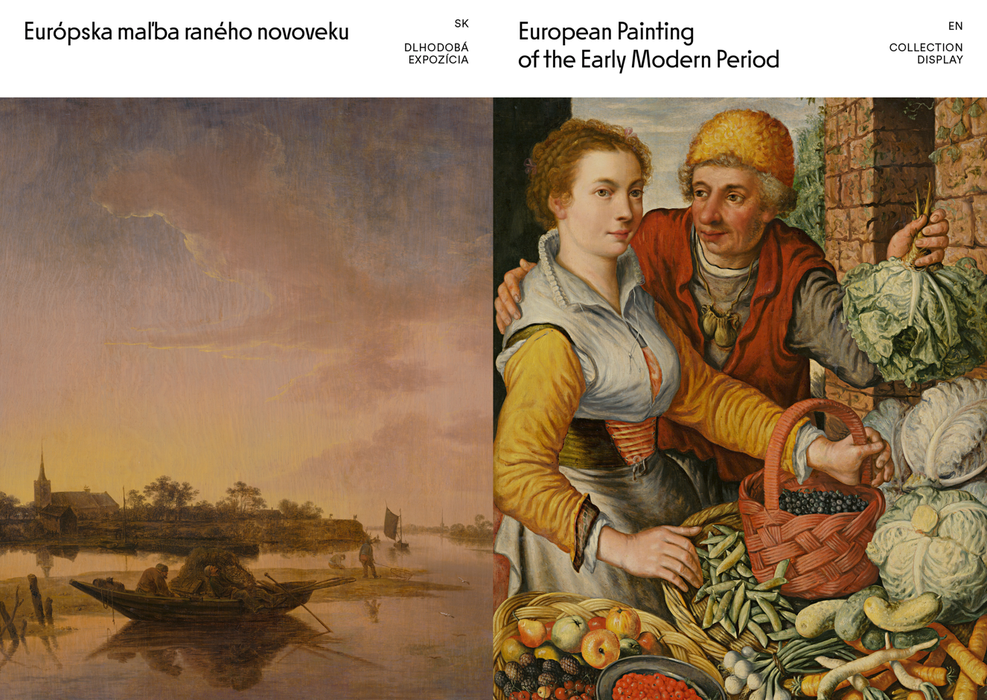
European Painting of the Early Modern Period │ This selection of European paintings of the 16th – 18th centuries of the Slovak National Gallery follows the transformation of private spaces under the influence of the social, religious and economic changes of the time.
The curatorial selection combines knowledge from the latest art history findings with research into the lifestyle, and housing and material culture in Western European households. The exhibited genre paintings, portraits, landscapes, and still lifes document not only the taste of the period, but map a path full of bold experiments leading up to the threshold of Modernism.
You will get to know the first-class works of Italian, Netherlandish, Dutch and other masters such as Hans von Aachen, Cecco del Caravaggio, Joachim Beuckelaer, Bartolomé Esteban Murillo, Gottfried Kneller, and through them you will be transported to Venice, Milan, Amsterdam, and Antwerp, the most important art centers of those times.
Around the middle of the 16th century, the first works of unusual importance were created; they exclusively featured secular themes where artists turned functional sacred objects into an earthly world of experiences. Collectors, patrons, and commissioners of art competed with each other in the decoration of interiors, which reflected their social status. The historical, and at first glance realistic paintings that decorated them, usually had a symbolic meaning.
Curator: Zuzana Ludiková
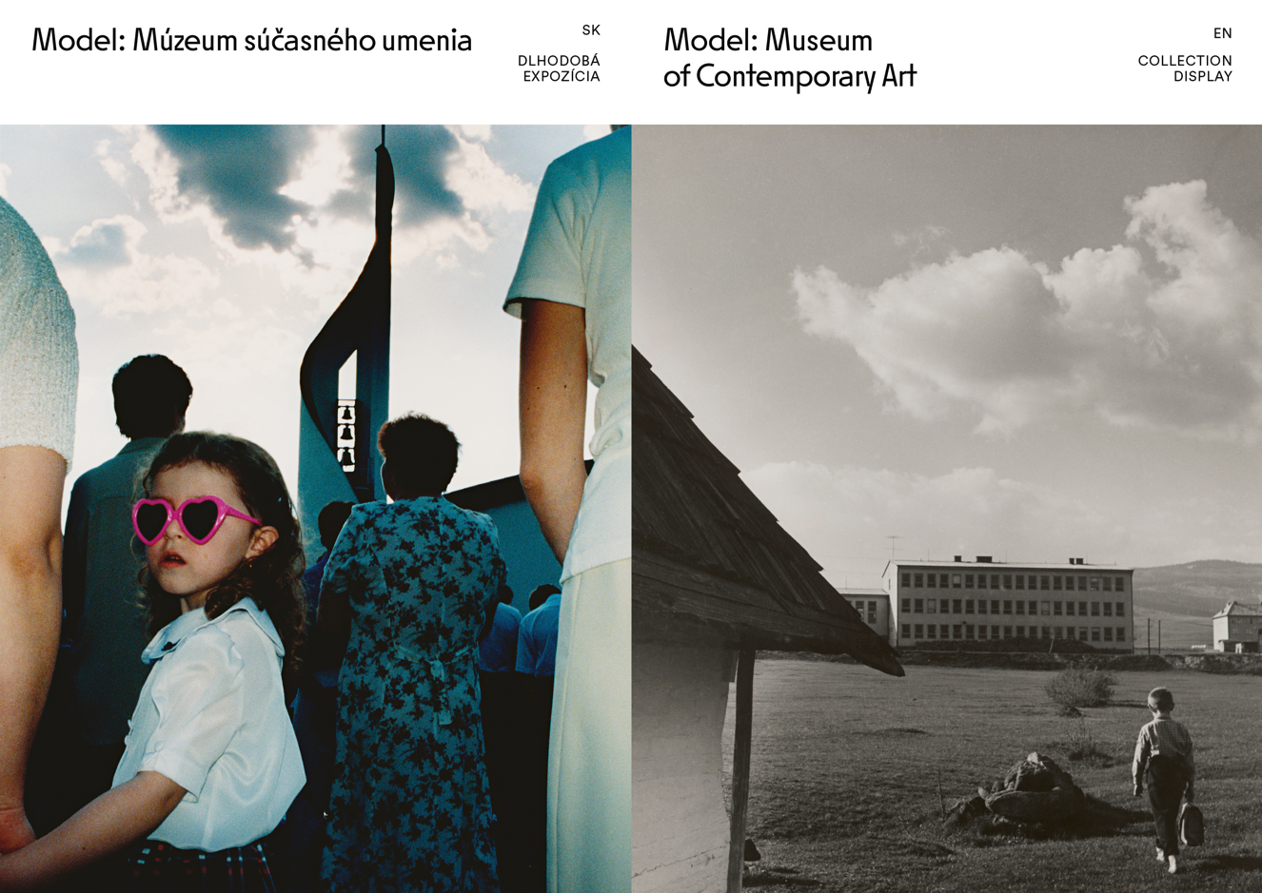
Model: Museum of Contemporary Art │ This exposition presents expressions of culture, society, and art dating from the 1950s up to the present.
It explores, through works by artists from Slovakia as well as Eastern Europe and around the world, interactions between the works of a variety of “contemporary” layers. The selection, from the newest
art in SNG collections, has not been arranged in chronological order, and it will be steadily altered, in part because of the fragile and ephemeral nature of the exhibited works’ media and techniques.
Typically, museums are associated with conserving the past, creating and preserving a canon of art history. By contrast, the term “contemporary art” has adjustable boundaries: contemporary art works are innovative and experimental, and often unconventional too. Therefore our simulated “Museum of Contemporary Art” is no repository of valuable artefacts, but more a performative collection in public space: an arena for discussion. It represents a range of attitudes, convictions, and topics from artists male and female, by way of curator strategies, research, and collection-building activities over the long term, by a considerable number of experts throughout the SNG’s existence.
Curator: Lucia Gregorová Stach
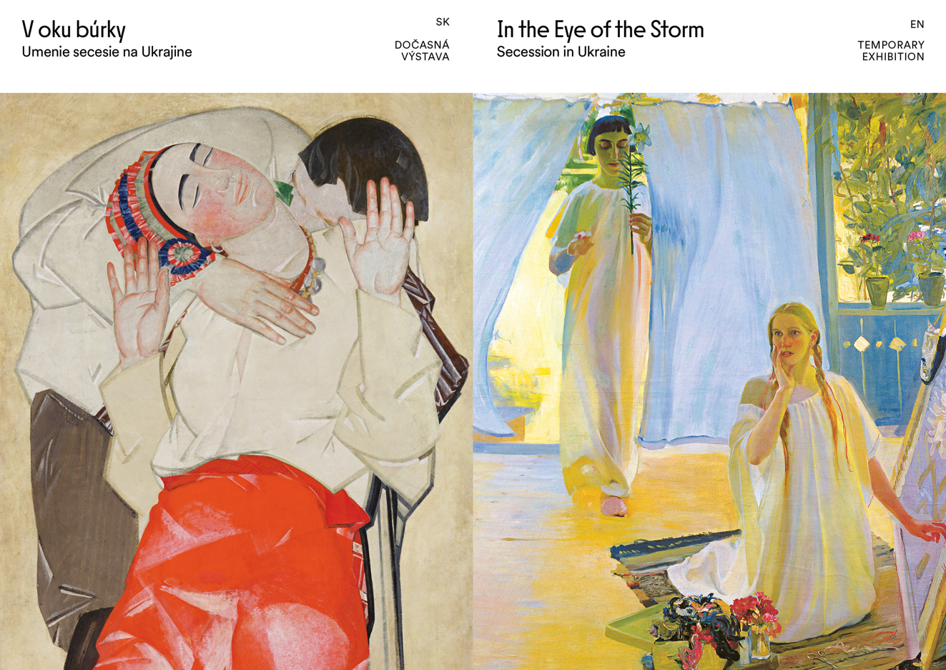
In the Eye of the Storm │ The exhibition presents approximately 50 works of secession art, a movement that culminated in Europe in around 1900 and extended to the territory of today’s Ukraine.In Central Europe, Vienna was an important centre of secession art, led by the influential figure of Gustav Klimt. In several centres, secession – the so-called last great international style – was manifested in the context of national specificities. In Ukraine, as in other countries, development of a new national school coincided with the rediscovery of folk art, organisation of applied art workshops in rural areas, and emergent work of artists associated with this environment.
In addition to striving to create a distinctive national visual language, some artists explored a highly personalised symbolist style often influenced by philosophical trends. The younger generation also drew on new currents of avant-garde art – cubofuturism or surrealism. Secession influence on the Ukrainian environment was relatively long lasting, continuing until the 1930s.
The exhibition project is held in collaboration with the Belvedere Gallery in Vienna, the National Gallery in Sofia, the National Art Museum of Ukraine in Kyiv, and other Ukrainian collections. The project was initiated by the Thyssen-Bornemisza National Museum in Madrid to express support for Ukraine and to protect its artworks from the Russian invasion. The exhibition at the SNG was initiated by Belvedere, Vienna.
We would like to thank the Embassy of Ukraine in the Slovak Republic for cooperation, the National Museum of Art of Ukraine, the National Museum of Andrey Sheptytsky in Lviv, the Museum of Art in Dnipro, the Mykola Yaroshenko Museum of Art in Poltava and the Museum of Contemporary Art in Odessa for lending us their works. We would like to thank the Ministry of Culture of the Slovak Republic for their collegial help in transporting the works to Slovakia.
Curators: Konstantin Akinsha, Maryna Drobotiuk
General partner SNG



